Seminar Report 2
SUO Dingyang 2216110081
PART I

Topic
Understand the working principle of the three-phase bridge fully controlled rectifier circuit in the two modes of rectification and active inversion. Analyze the on-order of individual components, and the measured voltage and current waveform is statistically analyzed. The experimental data obtained are compared with the theory and analyzed to give conclusions.

Simulation Model
Figure 1: Rectification Mode
Figure 2: Active Inversion Mode
In this part, the simulation is based on three-phase full bridge rectifier (thyristor version) with inductive load. Rectification mode and active inversion mode are shown in the image above.
These characteristics to be specified:
- Carry out simulations and analyze:
- Whether the system works under Rectification Mode (AC/DC)
OR Active Inversion Mode (DC/AC)
- The sequence of driving signal of each thyristor
- The ON and OFF state of each thyristor
- Do theoretical calculations of:
- Average value of DC-link voltage Vd
- Average value of DC-link current Id
- RMS value of AC side current
- RMS value of the current flowing through a Thyristor
- Compare theoretical results with simulation results and give necessary comments.

Simulation model of rectification mode
This model is established to find out the operating principle of three-phase full bridge rectifier circuit in the rectification mode., and get the values of the parameters of this model.
Simulink simulation is used in this simulation, and the simulated circuit diagram for three-phase full bridge rectifier (thyristor version) with inductive load in rectification is built as shown in the figure below.
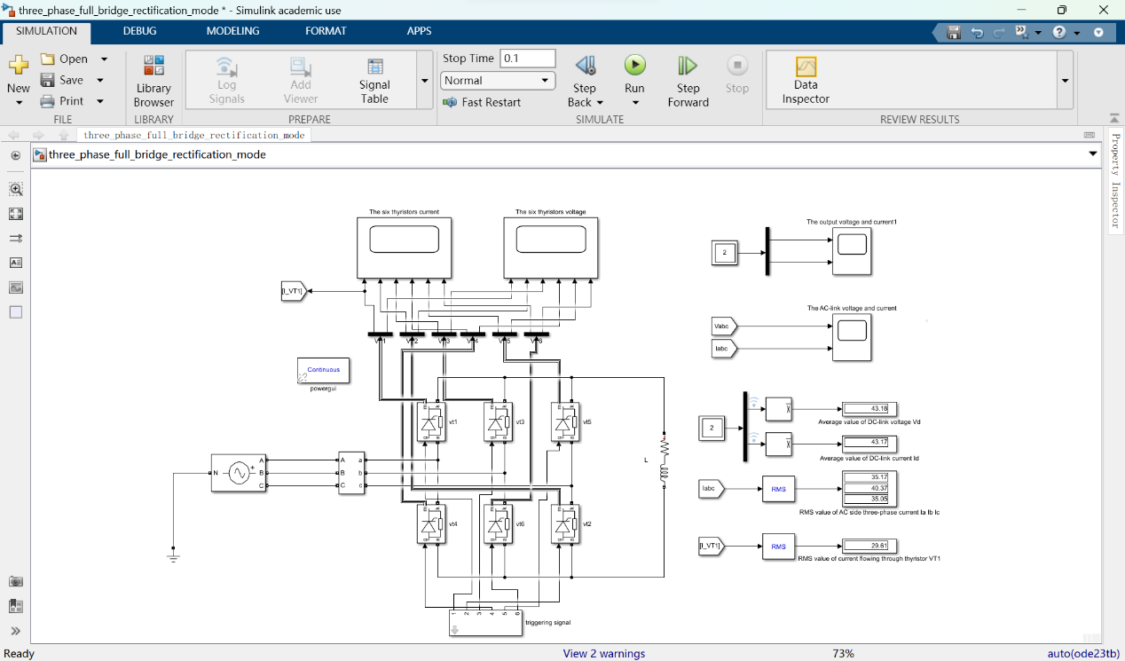
Figure 3: rectification mode of three-phase full bridge rectifier circuit in simulation
We used a three-phase power supply, 6 thyristors, and 6 signal generators (packaged as a subsystem) which were placed at the bottom to form the main circuit according to the connection of the three-phase bridge rectifier circuit. The rest is a measurement circuit, using three oscilloscopes, measuring the voltage and current of the six thyristors, output voltage and current.
The bottom right-hand corner of the image shows average value of DC-link voltage V_{d}, average value of DC-link current I_{d}, RMS value of the current flowing through a Thyristor I_{VT1} and RMS value of AC side current I_{a}, I_{b}, I_{c}.

Simulation model of active inversion mode
This model is established to find out the operating principle of three-phase full bridge rectifier circuit in the active inversion mode., and get the values of the parameters of this model.
Simulink simulation is used in this simulation, and the simulated circuit diagram for three-phase full bridge rectifier (thyristor version) with electromotive force load and inductive load in rectification is built as shown in the figure below.

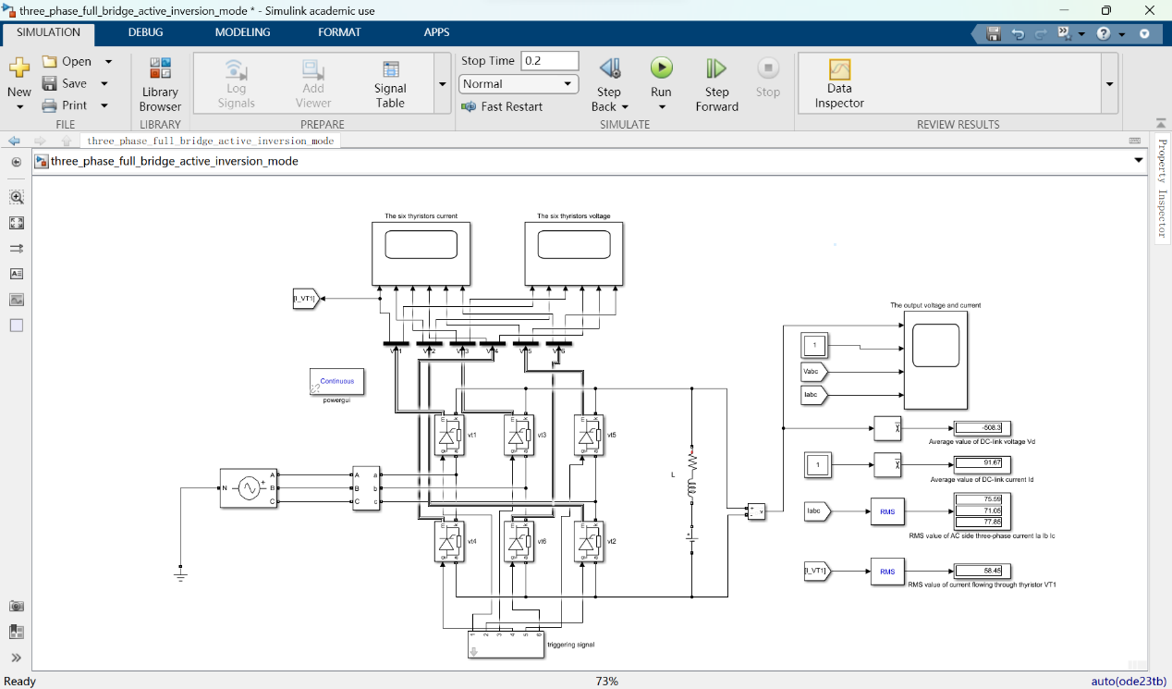
Figure 4: active inversion mode of three-phase full bridge rectifier circuit in simulation
We used a three-phase power supply, 6 thyristors, and 6 signal generators (packaged as a subsystem) which were placed at the bottom to form the main circuit according to the connection of the three-phase bridge rectifier circuit. But unlike the previous one, here the DC side has an inverse EMF of -600V, and the triggering angle $α$ is equal to 170$°$ The rest is a measurement circuit, using three oscilloscopes, measuring the voltage and current of the six thyristors, output voltage and current.
The bottom right-hand corner of the image shows average value of DC-link voltage V_{d}, average value of DC-link current I_{d}, RMS value of the current flowing through a Thyristor I_{VT1} and RMS value of AC side current I_{a}, I_{b}, I_{c}.

Parameter Setup
In this part, the AC side three-phase voltage source has the following specifications for both the first and the second simulation model:
RMS Value of Phase-To-AC-Neutral-Point Voltage: 220V
(i.e. RMS Value of Line-To-Line Voltage: 380V)
Line Frequency: 50Hz
With the consideration of parameters of firing angle $α_{1}, α_{2}$ , as well as $L, E, R$our group were assigned, those fixed parameters are listed below as a reference.
Other parameters about the simulation:
Stop time: 0.1 s
Maximum simulation step size:${10}^{-4}$ s
Table 1 parameters settings in simulation model of three-phase full bridge rectifier
L | R | E | $$α_{1}$$ | $$α_{2}$$
5mH | 1Ω | -600V | 85° | 170°

Simulation Results

Simulation results of the rectification mode
The first figure is a waveform of the output voltage and current on the DC side, the upper one is the output voltage $u_{d}$, and the bottom one is the current $i_{d}$.
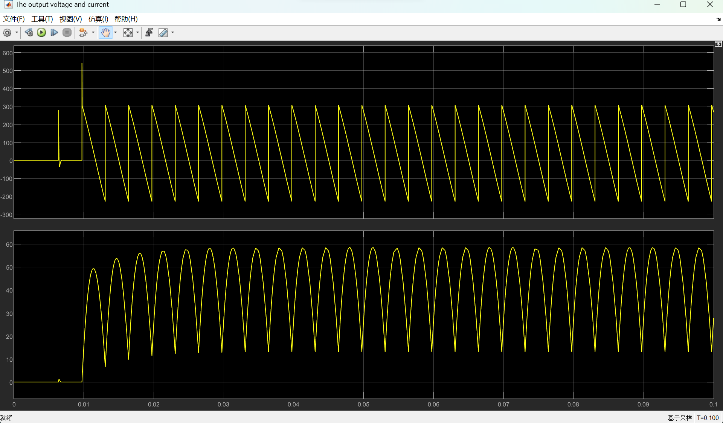
Figure 5: the DC-link voltage $u_{d}$ and current $i_{d}$ waveform of rectification mode
The figure below is the waveform of the AC-link voltage $u_{a}$, $u_{b}$, $u_{c}$, and current $i_{a}$, $i_{b}$, $i_{c}$, in rectification mode, the upper one is the phase-voltage, and the bottom one is the phase-current. The yellow line is the phase-a, the blue one is the phase-b, and the red one is the phase-c. From the waveform of the current, we can see that a, b, c three phases are alternately conducted.
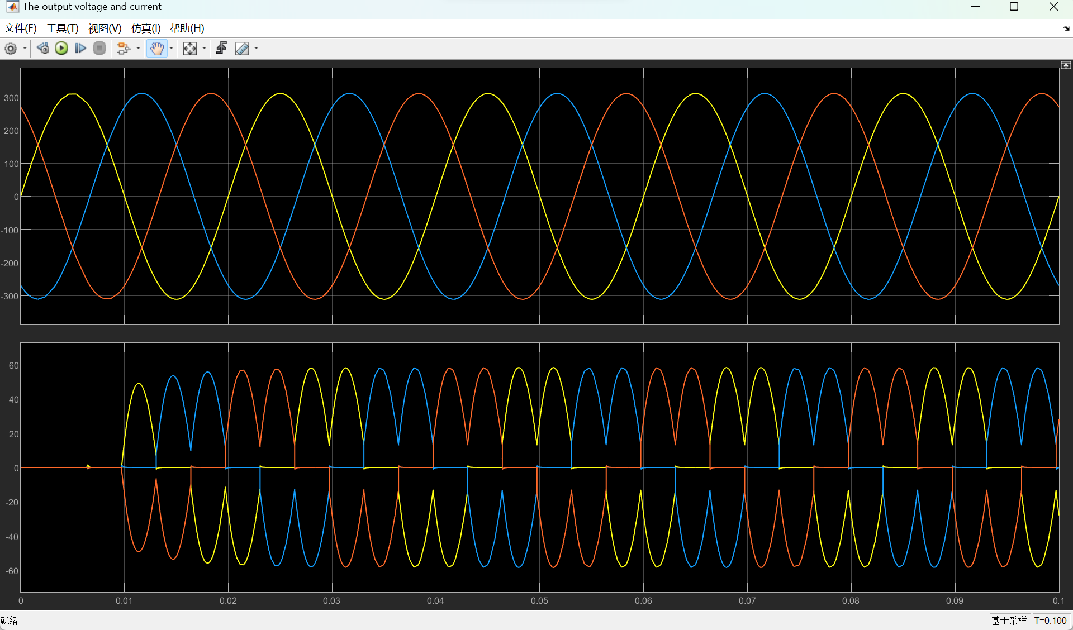
Figure 6: the AC-link voltage $u_{a}$, $u_{b}$, $u_{c}$ and current $i_{a}$, $i_{b}$, $i_{c}$ waveform of rectification mode
The figure below is the current waveform $i_{{VT}_{1}}$ $i_{{VT}_{2}}$ $i_{{VT}_{3}}$ $i_{{VT}_{4}}$ $i_{{VT}_{5}}$ $i_{{VT}_{6}}$ diagram of the six thyristors conducting, the thyristors are named respectively, the upper half group, ${VT}_{1}$, ${VT}_{3}$, ${VT}_{5}$, from left to right, the lower half group, ${VT}_{4}$, ${VT}_{6}$, ${VT}_{2}$, from left to right.
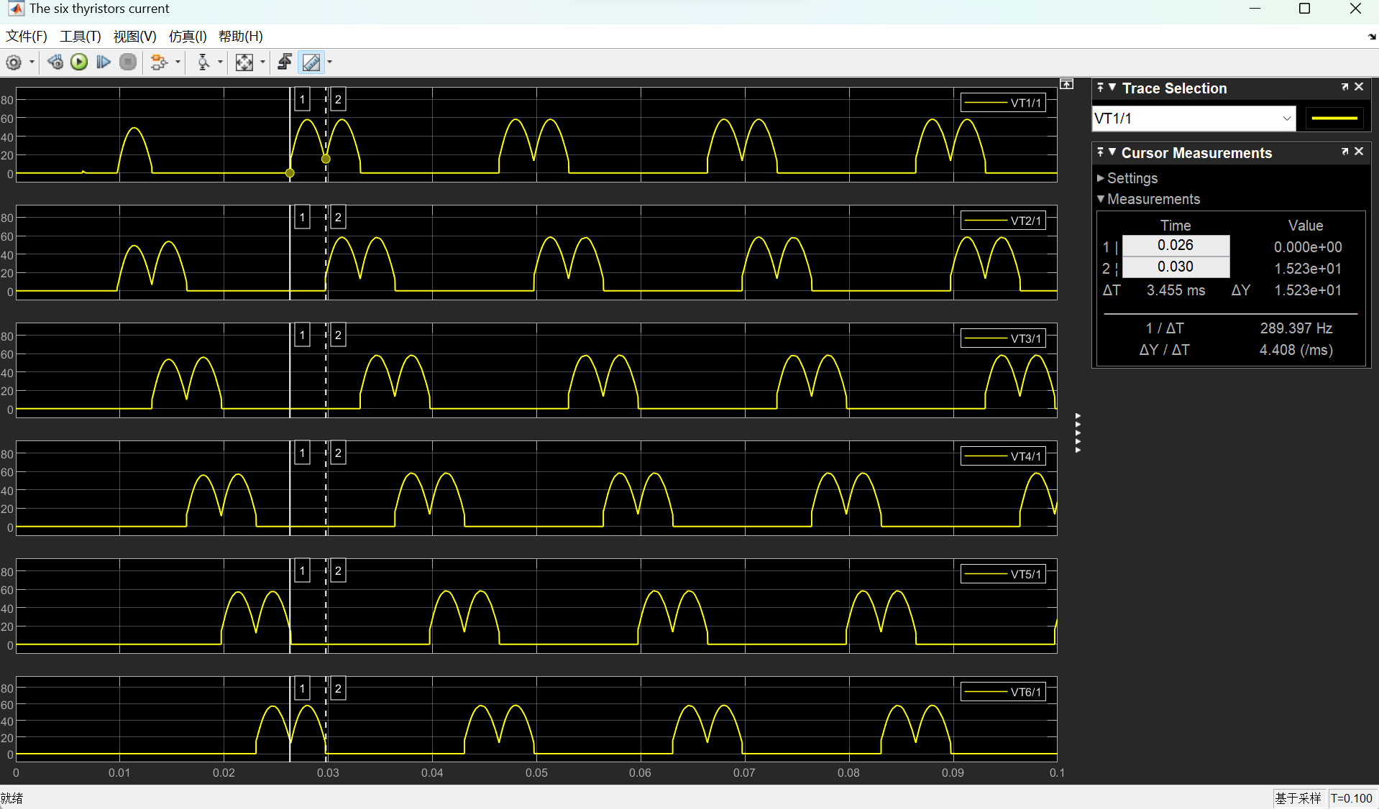
Figure 7: the six thyristors current $i_{{VT}_{1}}$ $i_{{VT}_{2}}$ $i_{{VT}_{3}}$ $i_{{VT}_{4}}$ $i_{{VT}_{5}}$ $i_{{VT}_{6}}$ waveform of rectification mode
By the Display component in Simulink, we can get the average and effective value of other given signal. Average value of DC-link voltage $U_{d}$. Average value of DC-link current $I_{d}$. RMS value of AC side current $I_{a}$, $I_{b}$, $I_{c}$. RMS value of the current flowing through a Thyristor $I_{{VT}_{1}}$.
Table 2: results in model rectification mode
U_{d}(V) | I_{d}(V) | RMS value of AC side current(A) | I_{VT1}(A)
43.18 | 43.17 | 35.17; 40.37; 35.05 | 29.61

Simulation results of active inversion mode
The first figure is a waveform of the output voltage and current on the DC side, the upper one is the output voltage $u_{d}$, and the bottom one is the current $i_{d}$, in active inversion mode. We added a -600V back EMF on the load side and changed the trigger angle to 170°.
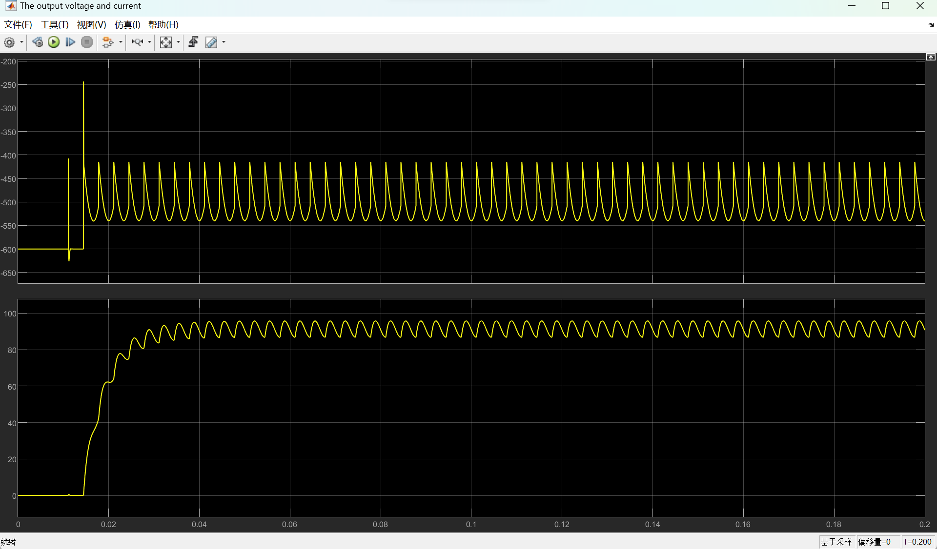
Figure 8: the DC-link voltage $u_{d}$ and current $i_{d}$ waveform of active inversion mode
The figure below is the waveform of the AC-link voltage $u_{a}$, $u_{b}$, $u_{c}$, and current $i_{a}$, $i_{b}$, $i_{c}$, in active inversion, the upper one is the phase-voltage, and the bottom one is the phase-current. The yellow line is the phase-a, the blue one is the phase-b, and the red one is the phase-c. From the waveform of the current, we can see that a, b, c three phases are alternately conducted.
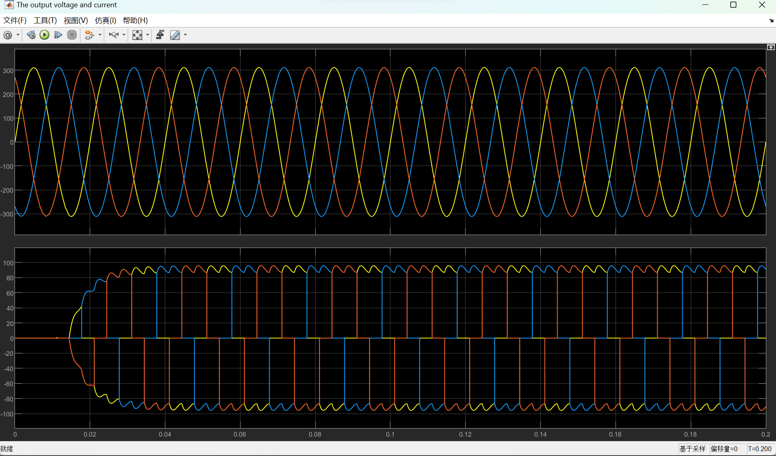
Figure 9: the AC-link voltage $u_{a}$, $u_{b}$, $u_{c}$ and current $i_{a}$, $i_{b}$, $i_{c}$ waveform of active inversion mode
The figure below is the current waveform $i_{{VT}_{1}}$ $i_{{VT}_{2}}$ $i_{{VT}_{3}}$ $i_{{VT}_{4}}$ $i_{{VT}_{5}}$ $i_{{VT}_{6}}$ diagram of the six thyristors conducting, the thyristors are named respectively, the upper half group, ${VT}_{1}$, ${VT}_{3}$, ${VT}_{5}$, from left to right, the lower half group, ${VT}_{4}$, ${VT}_{6}$, ${VT}_{2}$, from left to right.
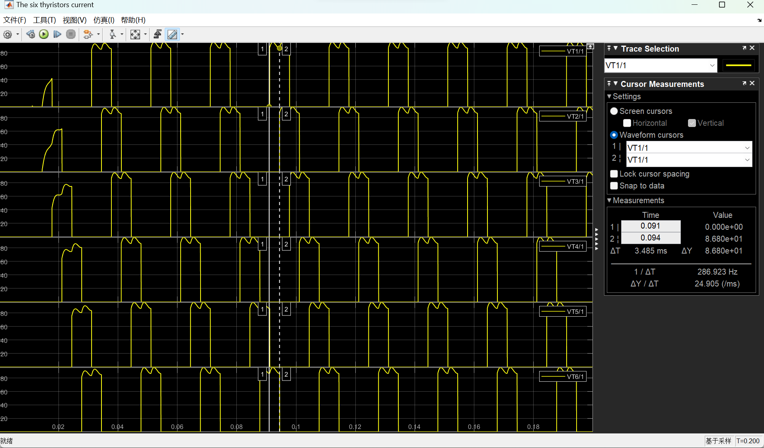
Figure 10: the six thyristors current $i_{{VT}_{1}}$ $i_{{VT}_{2}}$ $i_{{VT}_{3}}$ $i_{{VT}_{4}}$ $i_{{VT}_{5}}$ $i_{{VT}_{6}}$ waveform of active inversion mode
By the Display component in Simulink, we can get the average and effective value of other given signal. Average value of DC-link voltage $U_{d}$. Average value of DC-link current $I_{d}$. RMS value of AC side current $I_{a}$, $I_{b}$, $I_{c}$. RMS value of the current flowing through a Thyristor $I_{{VT}_{1}}$.
Table 3: results in model active inversion mode
U_{d}(V) | I_{d}(V) | RMS value of AC side current(A) | I_{VT1}(A)
-508.3 | 91.67 | 75.59; 71.05; 77.85 | 58.45

Analysis of the Results

Simulation analysis of rectification mode
Because the value of the load inductance is only 5mL, the current $i_{d}$ does not remain constant, but vibrates up and down, and from the figure below, we can see that because it is a three-phase bridge rectifier circuit, there are 6 pulses in one cycle.
Another thing worth noting is that at the beginning of the simulation, there are some strange changes in the waveform. That's because, at the beginning, because the circuit is not yet conducted, when the thyristors in the upper half group are on, such as ${VT}_{1}$, the thyristors in the lower half group are not yet conducted, such as ${VT}_{6}$, which produces some mutations that are different from steady-state operation.
From the figure 6, we can see that a, b, c three phases are alternately conducted. The results of simulation in the above illustrates the waveforms of driving signal of each thyristor and current flowing through them.
In figure 7 the stimulating signal for six thyristors are displayed in order, from ${VT}_{1}$ to ${VT}_{6}$. As we can see, all thyristors are triggered periodically. The triggering signals obey the rule that two thyristors are triggered at one time, and the sequence of triggering is $({VT}_{6}$,${VT}_{1})$—${(VT}_{1}$,${VT}_{2)}$—$({VT}_{2}$,${VT}_{3})$—$({VT}_{3}$,${VT}_{4)}$—${(VT}_{4}$,${VT}_{5})$—$({VT}_{5}$,${VT}_{6})$. So each thyristor conduct $\frac{1}{3}$ of the whole cycle. If the thyristors are named respectively, the upper half group, ${VT}_{1}$, ${VT}_{3}$, ${VT}_{5}$, from left to right, the lower half group, ${VT}_{4}$, ${VT}_{6}$, ${VT}_{2}$, from left to right.
Theoretical calculations for the first model are listed here. If we considered that the value of the inductance is large enough, and we ignore the pulsation of the DC current.
Table 4 theoretical calculations result of rectification model
parameters | Approximate calculation formula | The calculated value | Measured  value | error
average DC-link voltage | $$U_{d}=2.34U_{2}cosα$$ | 44.87 | 43.18 | 3.8%
average DC-link current | $$I_{d}=\frac{U_{d}}{R}$$ | 44.87 | 43.17 | 3.8%
RMS AC side current | $$I_{2}=\sqrt{\frac{2}{3}}I_{d}$$ | 36.64 | 35.17 | 4.0%
RMS Thyristor current | $$I_{VT}=\sqrt{\frac{1}{3}}I_{d}$$ | 25.91 | 29.61 | 14%
There are some errors between the theoretical value and the measured value, but the first three errors are not very large, but the final measurement of the effective value of the thyristor has a large error.
After discussion, our group believes that there are three main reasons:
First, In theoretical calculations, we consider that the inductor value is large enough for the load current $i_{d}$ to remain unchanged and it is equal to $I_{d}$, Other values calculated after that are calculated on the basis of this condition according to the theoretical model of square wave, so if the actual current waveform is not a square wave, it will produce a large error, especially the current of the thyristor and the current of the three-phase power supply.
Another reason is that there are something wrong at the beginning of the simulation. That's because, at the beginning, because the circuit is not yet conducted, when the thyristors in the upper half group are on, such as ${VT}_{1}$, the thyristors in the lower half group are not yet conducted, such as ${VT}_{6}$, which produces some mutations that are different from steady-state operation. Our theoretical values are calculated from the voltage and current waveforms at steady state, while the experimental measurements are RMS and averages from the very beginning to the end
The last reason is that there are some snubber resistance and snubber capacitor in the integrated three phase bridge we used. Besides, the thyristors which are considered as ideal devices in theory were not able to be treated as ideal ones.

Simulation analysis of active inversion mode
For the second model, there exists a counter electromotive source at the load terminal, so the circuit has to work in active inversion mode when the triggering angle $α={170}^{0}$.
In figure 7 the stimulating signal for six thyristors are displayed in order, from ${VT}_{1}$ to ${VT}_{6}$. As we can see, all thyristors are triggered periodically. The triggering signals obey the rule that two thyristors are triggered at one time, and the sequence of triggering is $({VT}_{6}$,${VT}_{1})$—${(VT}_{1}$,${VT}_{2)}$—$({VT}_{2}$,${VT}_{3})$—$({VT}_{3}$,${VT}_{4)}$—${(VT}_{4}$,${VT}_{5})$—$({VT}_{5}$,${VT}_{6})$. So each thyristor conduct $\frac{1}{3}$ of the whole cycle.
Theoretical calculations for the first model are listed here. If we considered that the value of the inductance is large enough, and we ignore the pulsation of the DC current.
Table 4 theoretical calculations result of rectification model
parameters | Approximate calculation formula | The calculated value | Measured  value | error
average DC-link voltage | $$U_{d}=-2.34U_{2}cosβ$$ | -507.0 | -508.3 | 0.26%
average DC-link current | $$I_{d}=\frac{U_{d}-E}{R}$$ | 93.0 | 91.67 | 1.4%
RMS AC side current | $$I_{2}=\sqrt{\frac{2}{3}}I_{d}$$ | 75.93 | 75.59 | 0.44%
RMS Thyristor current | $$I_{VT}=\sqrt{\frac{1}{3}}I_{d}$$ | 53.69 | 58.45 | 8.9%
After discussion, our group believes that there are three main reasons:
First, In theoretical calculations, we consider that the inductor value is large enough for the load current $i_{d}$ to remain unchanged and it is equal to $I_{d}$, it will produce a large error, especially the current of the thyristor and the current of the three-phase power supply.
Another reason is that there are something wrong at the beginning of the simulation. That's because, at the beginning, because the circuit is not yet conducted, when the thyristors in the upper half group are on, such as ${VT}_{1}$, the thyristors in the lower half group are not yet conducted, such as ${VT}_{6}$, which produces some mutations that are different from steady-state operation.
The last reason is that there are some snubber resistance and snubber capacitor in the integrated three phase bridge we used. Besides, the thyristors which are considered as ideal devices in theory were not able to be treated as ideal ones.

PART II

Topic
Understand the working principle of the three-phase bridge rectifier (power diode) with capacitive load. Analyze the effect of the size of the load resistance on the individual performance of the circuit. And the relationship curve of load resistance for the output voltage average of the DC-link, the power factor of the entire circuit, and the total harmonic distortion of the current is obtained.

Simulation model
figure11: Diode bridge with capacitive load
In this part, the simulation is based on three-phase full bridge rectifier (diode version) with capacitive load. Each group will be assigned with different capacitance for dc side capacitor. It is required to carry out simulation and analyze how the variations of load resistor RL would influence the following items: Output voltage Vo = f(RL), Power factor PF = f(RL), THD = f(RL).
The following model in Simulink is established to figure out the working conditions of three-phase full bridge rectifier (diode) with capacitive load. We add a capacitor in parallel connection with load resistance

Simulation model of Diode bridge with capacitive load
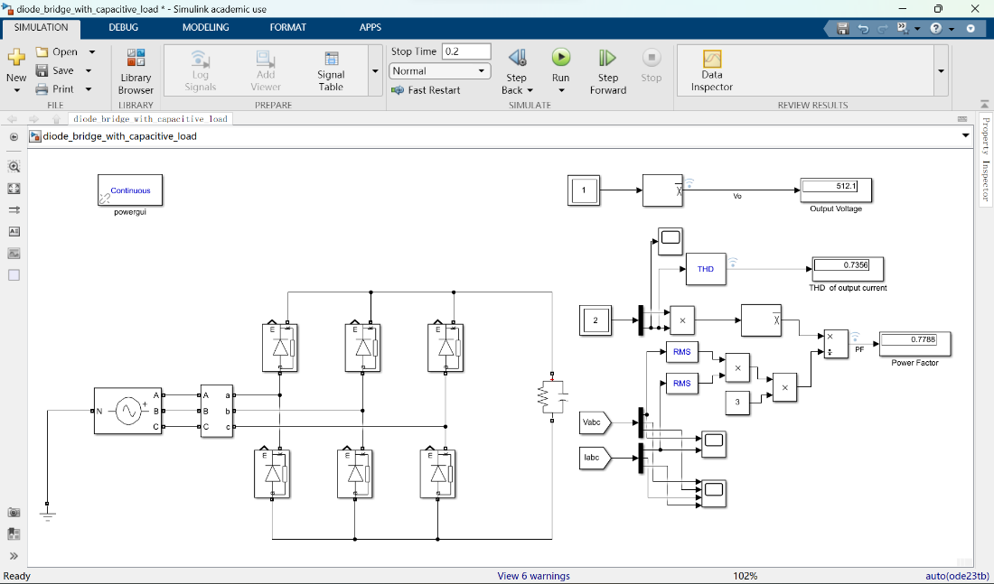
figure11: simulation circuit of Diode bridge with capacitive load

Parameters setup
In this part, the AC side three-phase voltage source remains the same specifications as those in PART 1, with a phase voltage of approximately 311V and 50Hz line frequency.
We still need to set the valve of capacitance and resistance. Considering about the data in appendix, we get a capacitor of 5 mF, and a set of resistance is listed in the figure.
Table 5 a set of resistances Value/$Ω$ with typical values
0.1 | 0.2 | 0.3 | 0.4 | 0.5 | 0.6 | 0.7 | 0.8 | 0.9 | 1.0
1 | 2 | 3 | 4 | 5 | 6 | 7 | 8 | 9 | 10
11 | 12 | 13 | 14 | 15 | 16 | 17 | 18 | 19 | 20
21 | 22 | 23 | 24 | 25 | 26 | 27 | 28 | 29 | 30
31 | 32 | 33 | 34 | 35 | 36 | 37 | 38 | 39 | 40
41 | 42 | 43 | 44 | 45 | 46 | 47 | 48 | 49 | 50
51 | 52 | 53 | 54 | 55 | 56 | 57 | 58 | 59 | 50
61 | 62 | 63 | 64 | 65 | 66 | 67 | 68 | 69 | 70
71 | 72 | 73 | 74 | 75 | 76 | 77 | 78 | 79 | 80
81 | 82 | 83 | 84 | 85 | 86 | 87 | 88 | 89 | 80
91 | 92 | 93 | 94 | 95 | 96 | 97 | 98 | 99 | 100

Simulation results
The capacitor plays a vital role in this circuit. When a couple of diodes were conducted, output DC voltage equals to the largest line voltage of AC side. Not only does the voltage charge the capacitor, it is also consumed by the load. On the other hand, if none of the diodes is conducted, the capacitor will discharge to the load while output voltage will drop exponentially.
Next we managed to provide the following plots: Vo = f(R_{L})，PF = f(RL),THD = f(R_{L}). What we finally did is using matlab script, 10 numbers were selected from 0.1-1, and integers were selected from 1-100 as resistors R_{L} and get the corresponding steady-state values for Vo, power factor and THD with Simulink.

Analysis of the results
We stored the data in corresponding vectors and plotted them in MATLAB. The output voltage It increases as the load resistance increases.
Figure12: relationship between resistor value and power output voltage
The first figure illustrated relationship between resistor value and power output voltage. As it was shown in the figure, the average value of output voltage rises rapidly when the resistance is relatively small. As the resistance grows, the acceleration of output voltage drops.
Figure13: relationship between resistor value and power factor
The figure above demonstrates how the power factor varies with the resistance. The trend of variation is that the power factor declines with a lighter load namely a bigger resistance. There are some spikes in the graph, which we speculate may be caused by some resonant phenomenon in the internal circuitry
Figure14: relationship between resistor value and power factor
This figure displays the tendency of THD changes with the resistance. Generally speaking, the ratio of harmonics over fundamental wave is not fixed. The general trend is that the heavier the load is, the larger the THD is.

Script code display
a=0.1:0.1:1;
b=2:1:10;
c=10:1:100;
Rlm=[a,b,c];
clc
Rl=10;
LengthRl=length(Rlm);
resultsVo=zeros(1,LengthRl);
resultsPF=zeros(1,LengthRl);
resultsTHD=zeros(1,LengthRl);
for k=1:LengthRl
modelname='diode_bridge_with_capacitive_load';
load_system(modelname);
Rl=Rlm(k);
K;
cs=getActiveConfigSet(modelname);
model_cs=cs.copy;
simOut=sim(modelname,model_cs);
L=length(simOut.logsout{1}.Values.Data);
results_Vo=simOut.logsout{1}.Values.Data(L)
results_PF=simOut.logsout{2}.Values.Data(L)
results_THD=simOut.logsout{3}.Values.Data(L)
resultsVo(k)=results_Vo;
resultsPF(k)=results_PF;
resultsTHD(k)=results_THD;
end
subplot(2,2,1)
plot(Rlm,resultsVo,'Linewidth',1.5);
grid on
title('\itOutput Voltage varies with Load resistance')
xlabel('\itR_l /\Omega')
ylabel('\itU_d /V')
subplot(2,2,2)
plot(Rlm,resultsPF,'Linewidth',1.5)
grid on
title('\itPower factor varies with Load resistance')
xlabel('\itR_l /\Omega')
ylabel('\it')
subplot(2,2,3)
plot(Rlm,resultsTHD,'Linewidth',1.5)
grid on
title('\itTHD varies with Load resistance')
xlabel('\itR_l /\Omega')
ylabel('\it')

